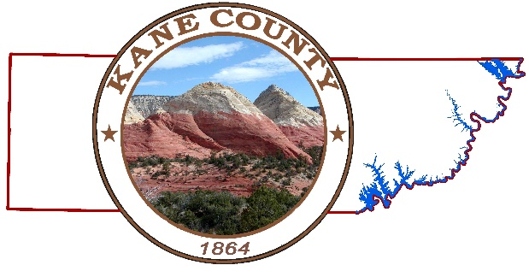

UOCAVA VOTERS 20A-16-502(1)

2024 DEMOCRATIC PRESIDENTIAL PRIMARY ELECTION

On March 5, 2024, Utah will be administering the 2024 Democratic Presidential Primary Election. Ballots will be mailed to registered Democratic voters, and to those who request a Democratic ballot before the February 23rd deadline.

Due to the Republican Party’s decision to hold a Presidential Preference Poll in their neighborhood caucus meetings, the County will not be mailing Republican Party ballots to voters. If you would like a Republican preference poll ballot, please contact the Republican Party at https://utgop.org/2024-presidential-preference- poll/.

2024 REGULAR PRIMARY ELECTION
On June 25, 2024, Utah will be administering the 2024 Regular Primary Election, (if one is needed).

2024 REGULAR GENERAL ELECTION
On November 5, 2024, Utah will be administering the 2024 Regular General Election.

Ballots will be mailed according to Utah Code 20A-16-403(1). More election and candidate information can be found at www.vote.utah.gov

The races that affect Washington County voters in 2024 are:

Federal races: County races:
U.S. President and Vice President, (4) year term Commissioner Seat C, (4) year term
U.S. Senate, (6) year term County Assessor, (4) year term
U.S. House of Representatives District 2, (2) year term County Recorder, (4) year term
County Treasurer, (4) year term
State races:
Governor (4) year term Local School Board
Lieutenant Governor (4) year term District 1, (4) year term
Attorney General (4) year term District 2, (4) year term
State Auditor (4) year term District 3, (4) year term
State Treasurer (4) year term District 3, (4) year term State Senate, Senate District 27 and 29, (4) year term
State House, Districts 72, 73, 74 and 75, (2) year term Ballot Propositions
State School Board District 15 (4) year term None at this time Kane County Elections

1 | P a g e

